**Globe Bulb**

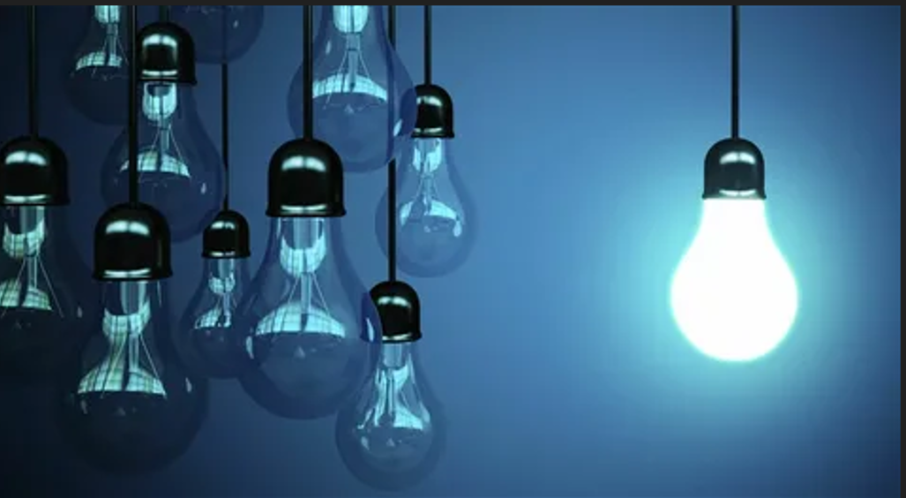

#### ****Description:****

**Globe Bulbs** are stylish, spherical lighting solutions designed to provide uniform and diffused light. These bulbs are perfect for decorative fixtures, pendant lights, and open-style lamps where the bulb itself is visible. With a modern and elegant design, Globe Bulbs add a touch of sophistication to any space.

* **Technology:** LED or incandescent (depending on the model).
* **Compatibility:** Standard E26/E27 base (fits most fixtures).
* **Bulb Type:** G25 (globe shape), G30 (medium globe shape), G40 (large globe shape).
* **Wattage:** 6W (LED, equivalent to 40W incandescent), 40W (incandescent).
* **Lumens:** 450 lumens (LED), 400 lumens (incandescent).
* **Color Temperature:** 2700K (warm white), 3000K (soft white), 5000K (daylight).
* **Dimmable:** Yes (select models).
* **Lifespan:** 25,000 hours (LED), 1,000 hours (incandescent).
* **Energy Efficiency:** LED models are Energy Star certified.

#### ****Key Features:****

* **Uniform Light Distribution:** Provides even and diffused light, ideal for decorative fixtures.
* **Energy-Efficient (LED Models):** Uses up to 85% less energy than traditional incandescent bulbs.
* **Modern Design:** Spherical shape adds a stylish touch to any fixture.
* **Dimmable Options:** Available in dimmable models for adjustable brightness.
* **Long Lifespan (LED Models):** Lasts up to 25,000 hours, reducing the need for frequent replacements.
* **Versatile Use:** Suitable for pendant lights, chandeliers, and open-style lamps.

#### ****Pricing:****

* **Single Bulb (LED, G25):** $14.99
* **Single Bulb (Incandescent, G25):** $9.99
* **4-Pack (LED, G25):** 49.99(49.99(12.50 per bulb)
* **4-Pack (Incandescent, G25):** 34.99(34.99(8.75 per bulb)

#### ****Where to Use:****

* **Pendant Lights:** Add a modern touch to your kitchen or dining area.
* **Chandeliers:** Enhance the elegance of your living room or entryway.
* **Open-Style Lamps:** Provide soft, diffused light for a cozy atmosphere.
* **Bathrooms:** Create a spa-like ambiance with warm, even lighting.
* **Retail Stores:** Highlight products with stylish and functional lighting.

### ****Customer Reviews:****

* ⭐⭐⭐⭐⭐ "These Globe Bulbs are stunning! They add so much character to my pendant lights. The light is soft and even, perfect for my dining area." – Sarah L.
* ⭐⭐⭐⭐ "Great value for the price. The bulbs are beautiful, and the light is very warm and inviting. Highly recommend for anyone looking to add a modern touch to their space." – James T.
* ⭐⭐⭐⭐⭐ "I love how energy-efficient the LED models are. The spherical design is a bonus!" – Emily R.

### ****How to Order:****

1. Visit our website: [www.brightworldlighting.com](http://www.brightworldlighting.com/)
2. Select your preferred bulb type and pack size (Single or 4-Pack).
3. Add to cart and proceed to checkout.
4. Enjoy free shipping on all orders over $50!

### ****Warranty and Support:****

* **Warranty:** 2-year limited warranty covering manufacturing defects (LED models).
* **Customer Support:** Contact us at [support@brightworldlighting.com](mailto:support@brightworldlighting.com) or call +1-800-123-4567 for assistance.